**Arithmetic Operators**

Arithmetic operators are math signs used to do mathematical operations in two numbers so it’s considered **binary** operators.

|  |  |  |
| --- | --- | --- |
| **Arithmetic Operators** | **sign** | **function** |
| **Addition Operator** | **+** | **sum of two numbers** |
| **Subtraction Operator** | **-** | **difference between two numbers** |
| **Multiplication Operator** | **\*** | **product of two numbers** |
| **Division Operator** | **/** | **quotient of division operation** |
| **Modulus Operator** | **%** | **remainder of division operation** |

**Example 1:**

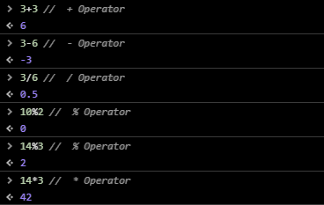

**Example 2: Expected: 0 1 2 0 1 2 0 1 2 0 1 2 0 1 2 0 1 2**

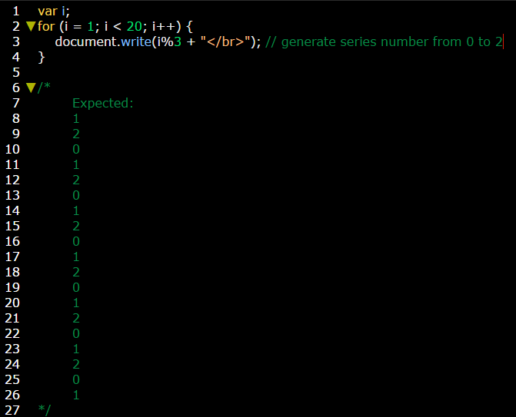

**Example 3:**

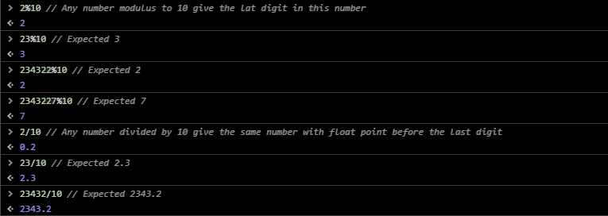

**Example:** on getting odd numbers by using loops and % operator.

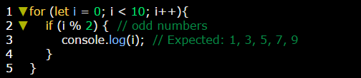

**Note:**

**+** can works as a **binary**, [**unary+**](unary+.docx), and **concatenate** operator.

**Interview Question:**

1. **How to return only the last digit in this number 3727? Use %10.**
2. **How to get this number except the last digit? Use /10 to get floating part then parseInt(number) function to rounded this number.**
3. **How to generate series numbers from starting number to ending number? Use %ending number.**